Anthony Frazier

CPT 247

Chapter One: Hands On

1-1

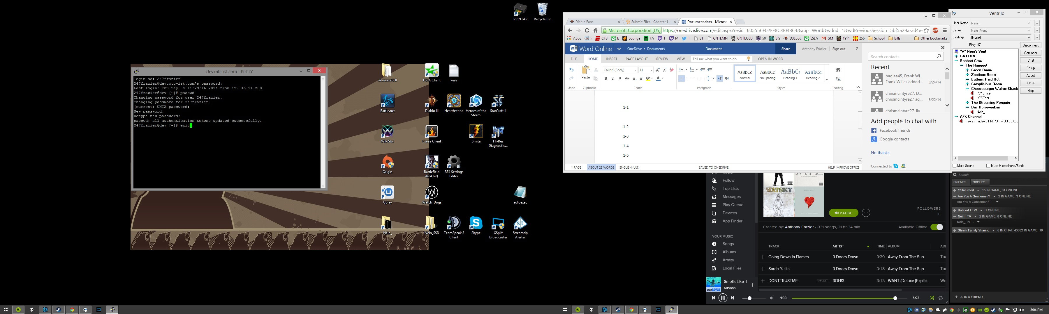

1-2 has us connect to a server using Fedora, Red Hat, or SUSE. Unable to accomplish.

1-3

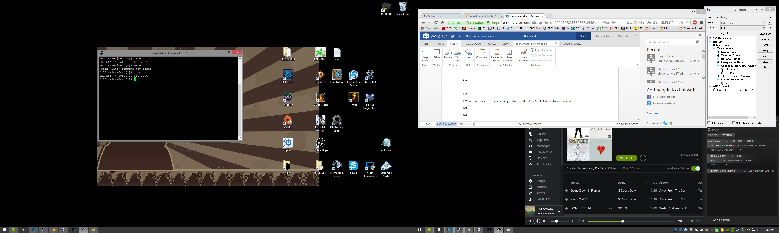

1-4

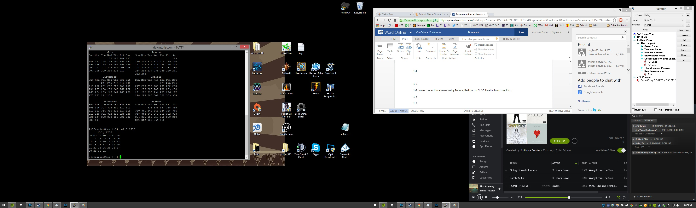

1-5

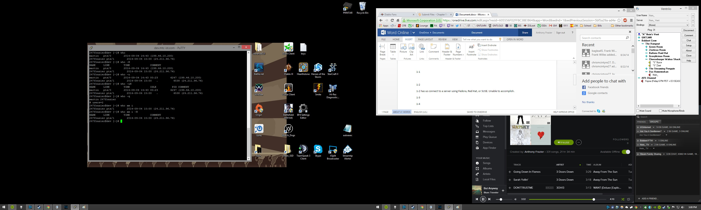

1-6

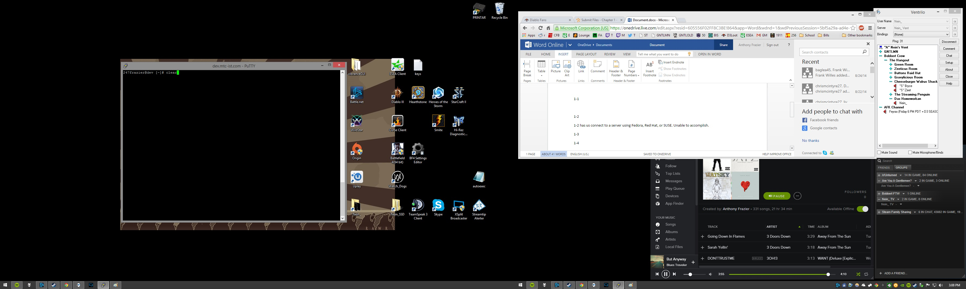

1-7

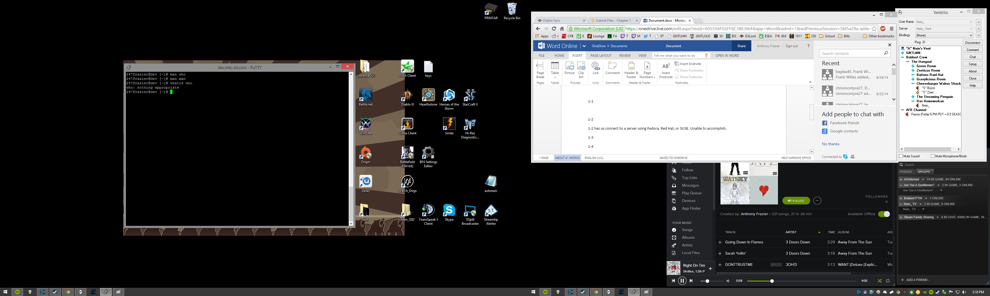

1-8

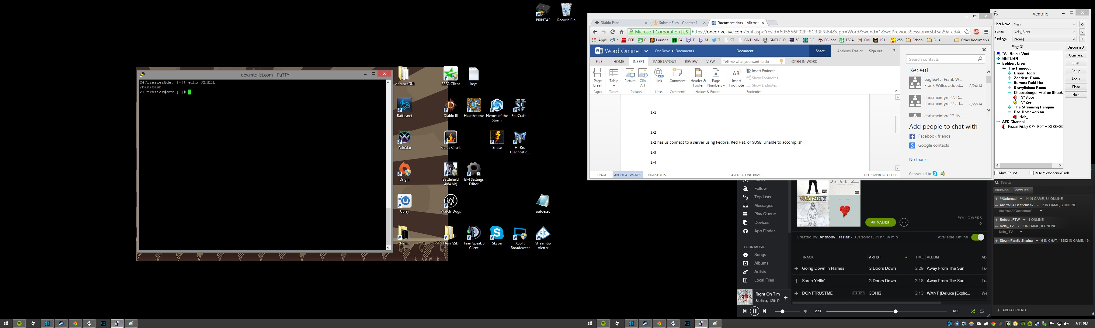

1-9

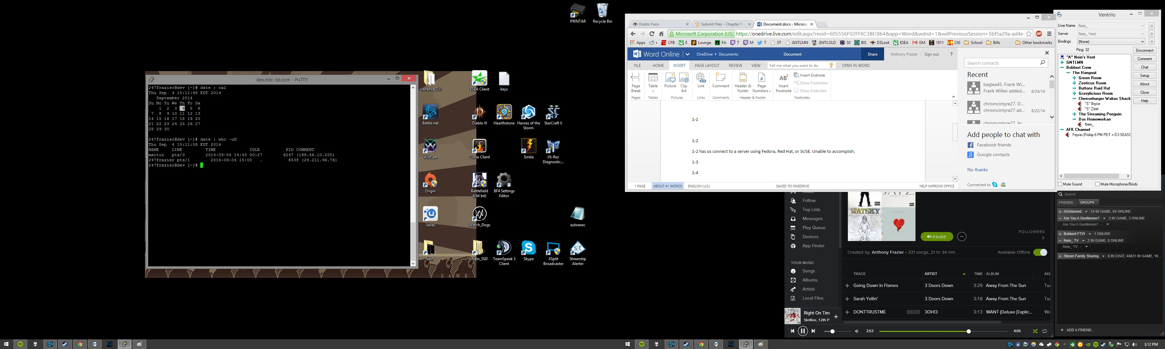

1-10

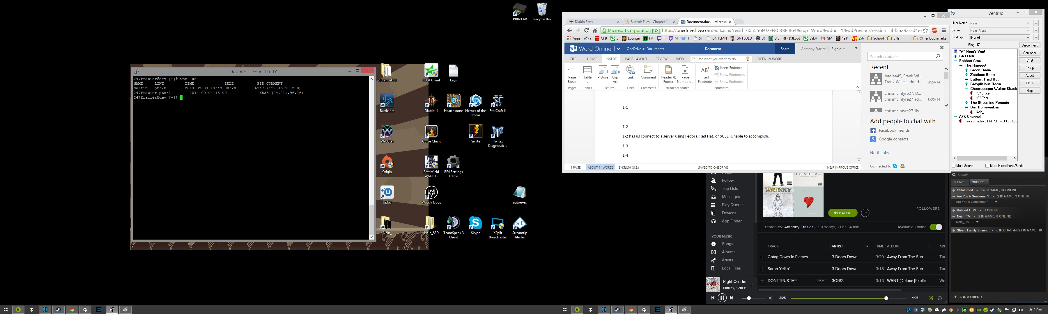

1-11 changed password as soon as I successfully logged into Putty, didn't want to change again

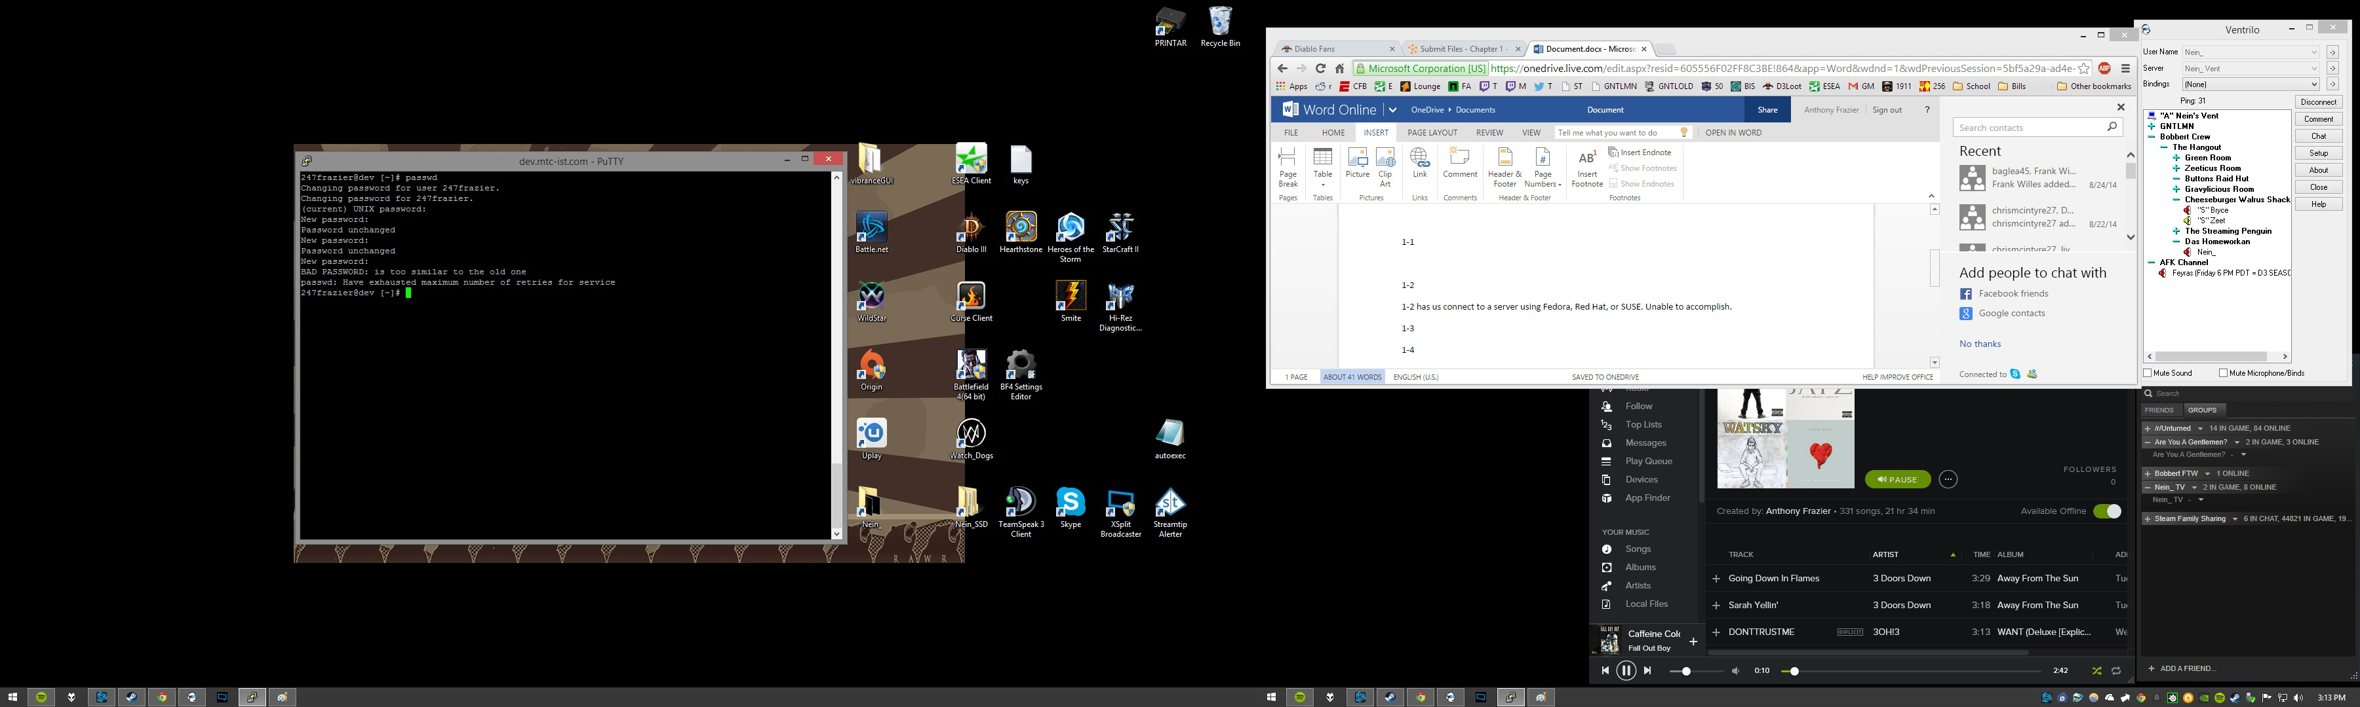

1-12

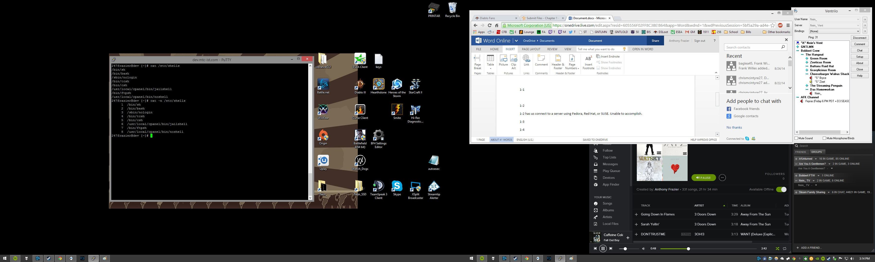

1-13 - unable to find file

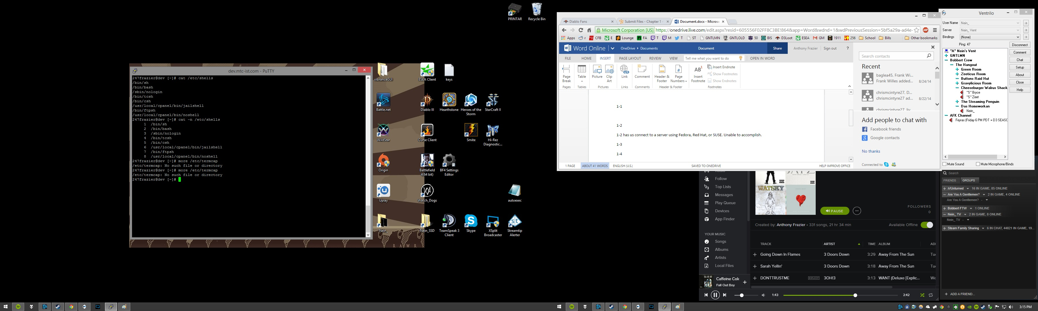

1-14 - unable to find file

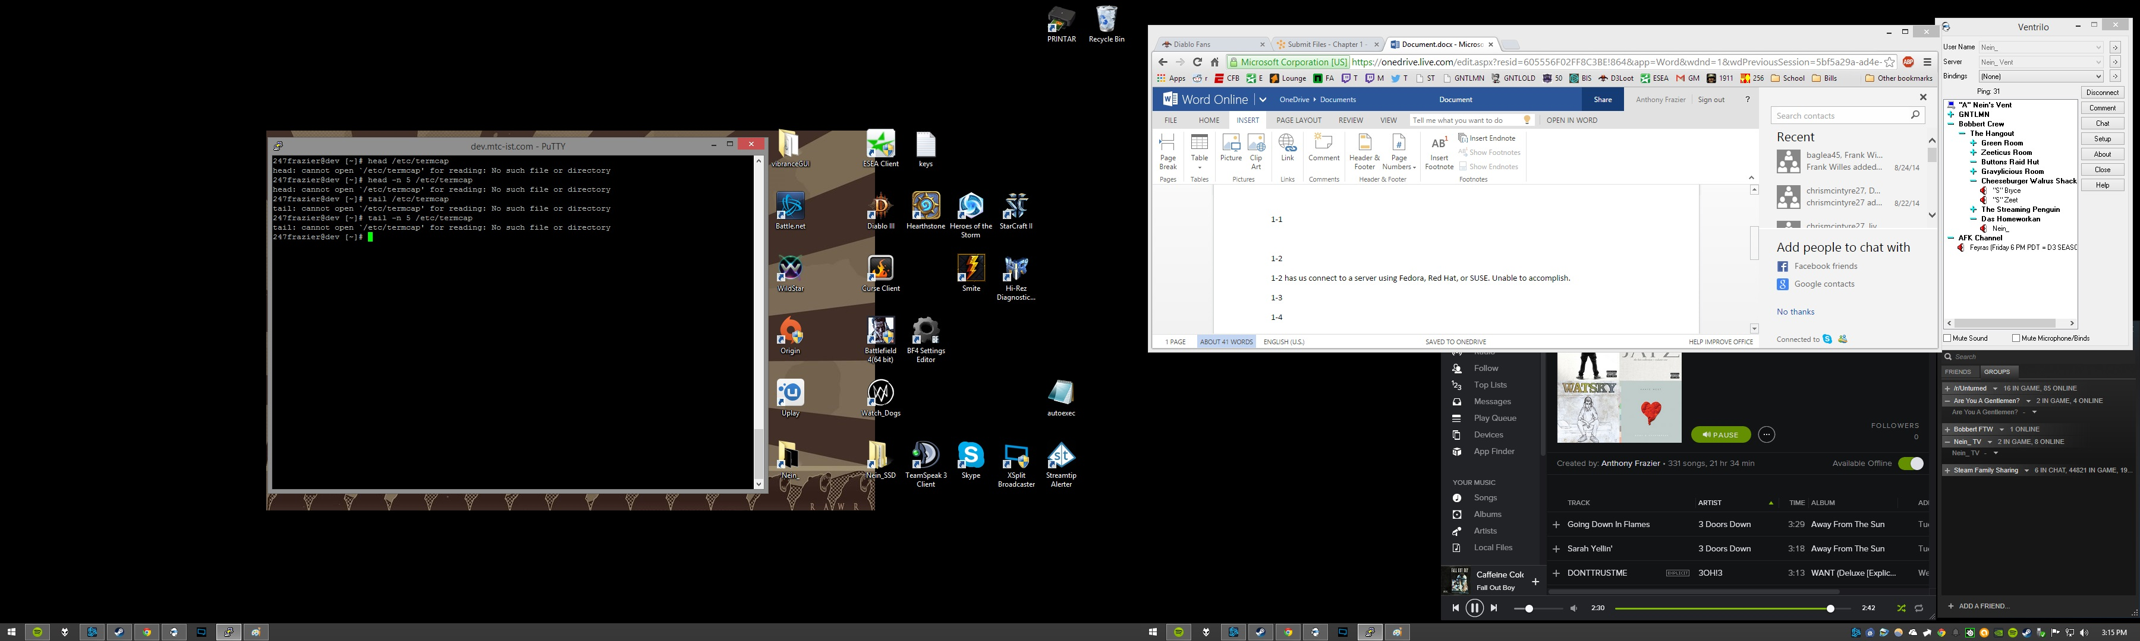

1-15

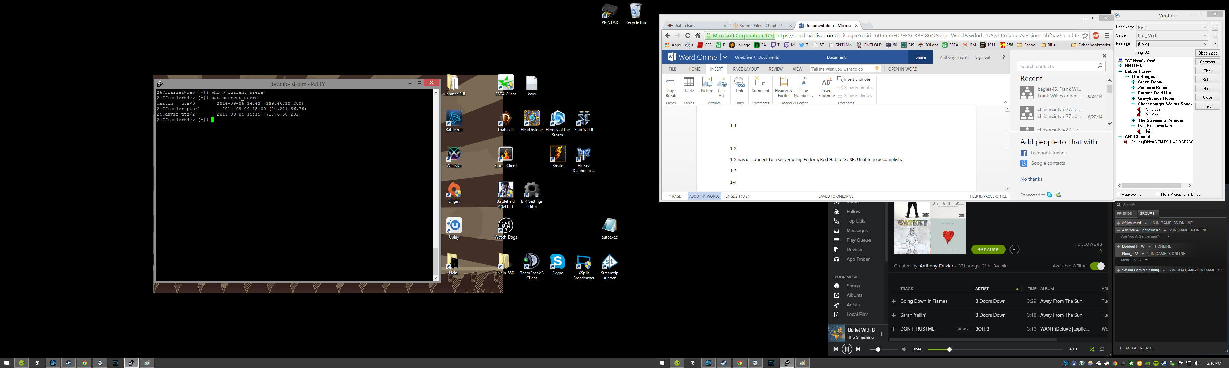

1-16

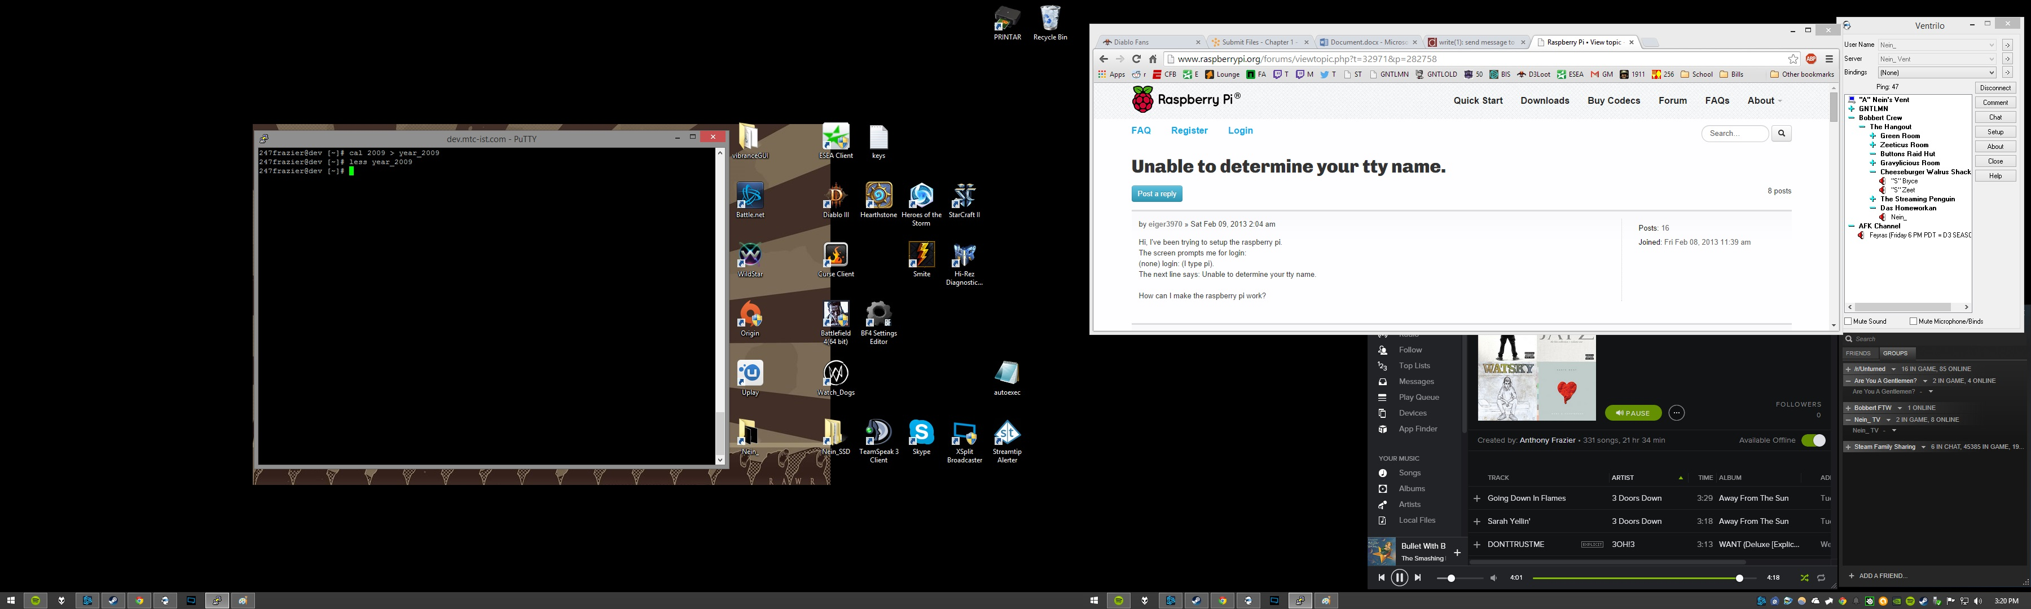

1-17

